Volunteer Application Form
Thank you for your offer to help with the West Berks Food Bank. 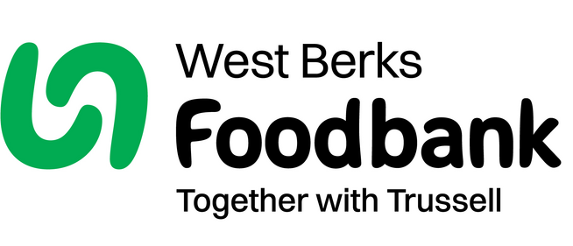
In order for us to process your application please would you
answer the following questions:

(If you have any questions about your application or would like help
completing it please contact us.)
HR Manager
West Berks Foodbank,
Unit 80, First Street,
Greenham Common Business Park,
Newbury, RG19 6HW

HR@westberks.foodbank.org.uk
www.westberks.foodbank.org.uk

Name:
Address:
Postcode:
Email Address:
Home Tel No:
Mobile Tel No:

Next of Kin: |  | Contact in case of emergency (if different from above)
Name: |  | Name:
Contact Tel No: |  | Contact Tel No:
Email Address: |  | Email Address:
Relationship: |  | Relationship

I would be interested in helping in the following area(s):

☐Helping in a Foodbank Centre (afternoons)
Newbury/Thatcham/Hungerford/Burghfield & Mortimer/Theale Calcot & Tilehurst/Greenham(Please delete those that do not apply)
☐Helping in Warehouse (mornings)
☐Driving – collections from supermarkets or deliveries to clients (mornings)
☐Assisting with Administration
☐Fundraising

I am available for:

☐Monday am | ☐Wednesday am | ☐Friday am
☐Monday pm | ☐Wednesday pm | ☐Friday pm
☐Tuesday am | ☐Thursday am
☐Tuesday pm | ☐Thursday pm

☐One off event i.e., supermarket collections, Harvest food sorting, Christmas box sorting

Please note that our Foodbank Centres are not open every day.
Full details of opening times can be found on our website.

I can offer |  | hours per week.

I can be flexible and available to be called on at short notice. ☐Yes ☐No

I hold a full current driving licence. ☐Yes ☐No

I have access to a car which I would be willing to use to support the work of West Berks Foodbank. ☐ Yes ☐ No

More about me.
Do you have any health problems that we should be aware of? ☐Yes ☐No
details:

Please tell us your previous relevant work experience or qualifications:

If you have any criminal convictions (except those ‘spent’ under the Rehabilitation of
Offenders Act) please give details:

We’re interested in knowing why you wish to volunteer – please state your motivation for volunteering for West Berks Foodbank

Please give us any information you think may be useful to us including where you heard about us.

References (Please not that your referees should not be either a close family connection or a Foodbank employee)

Referee : |  | Referee :
Name: |  | Name:
Address: |  | Address:
Postcode: |  | Postcode:
Contact Tel No: |  | Contact Tel no::
Email Address: |  | Email Address:

Date of Birth Day Month Year

Signature: ______________________ Date: __________________

Please email the completed form to HR@westberks.foodbank.org.uk, or post to our personnel team at the above address

