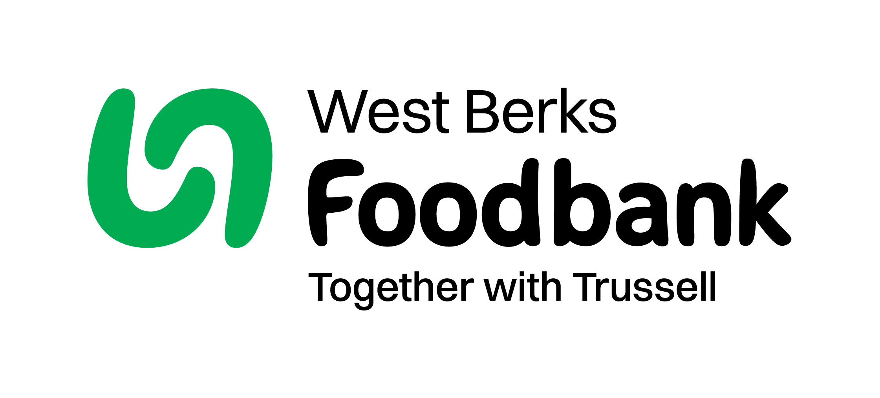
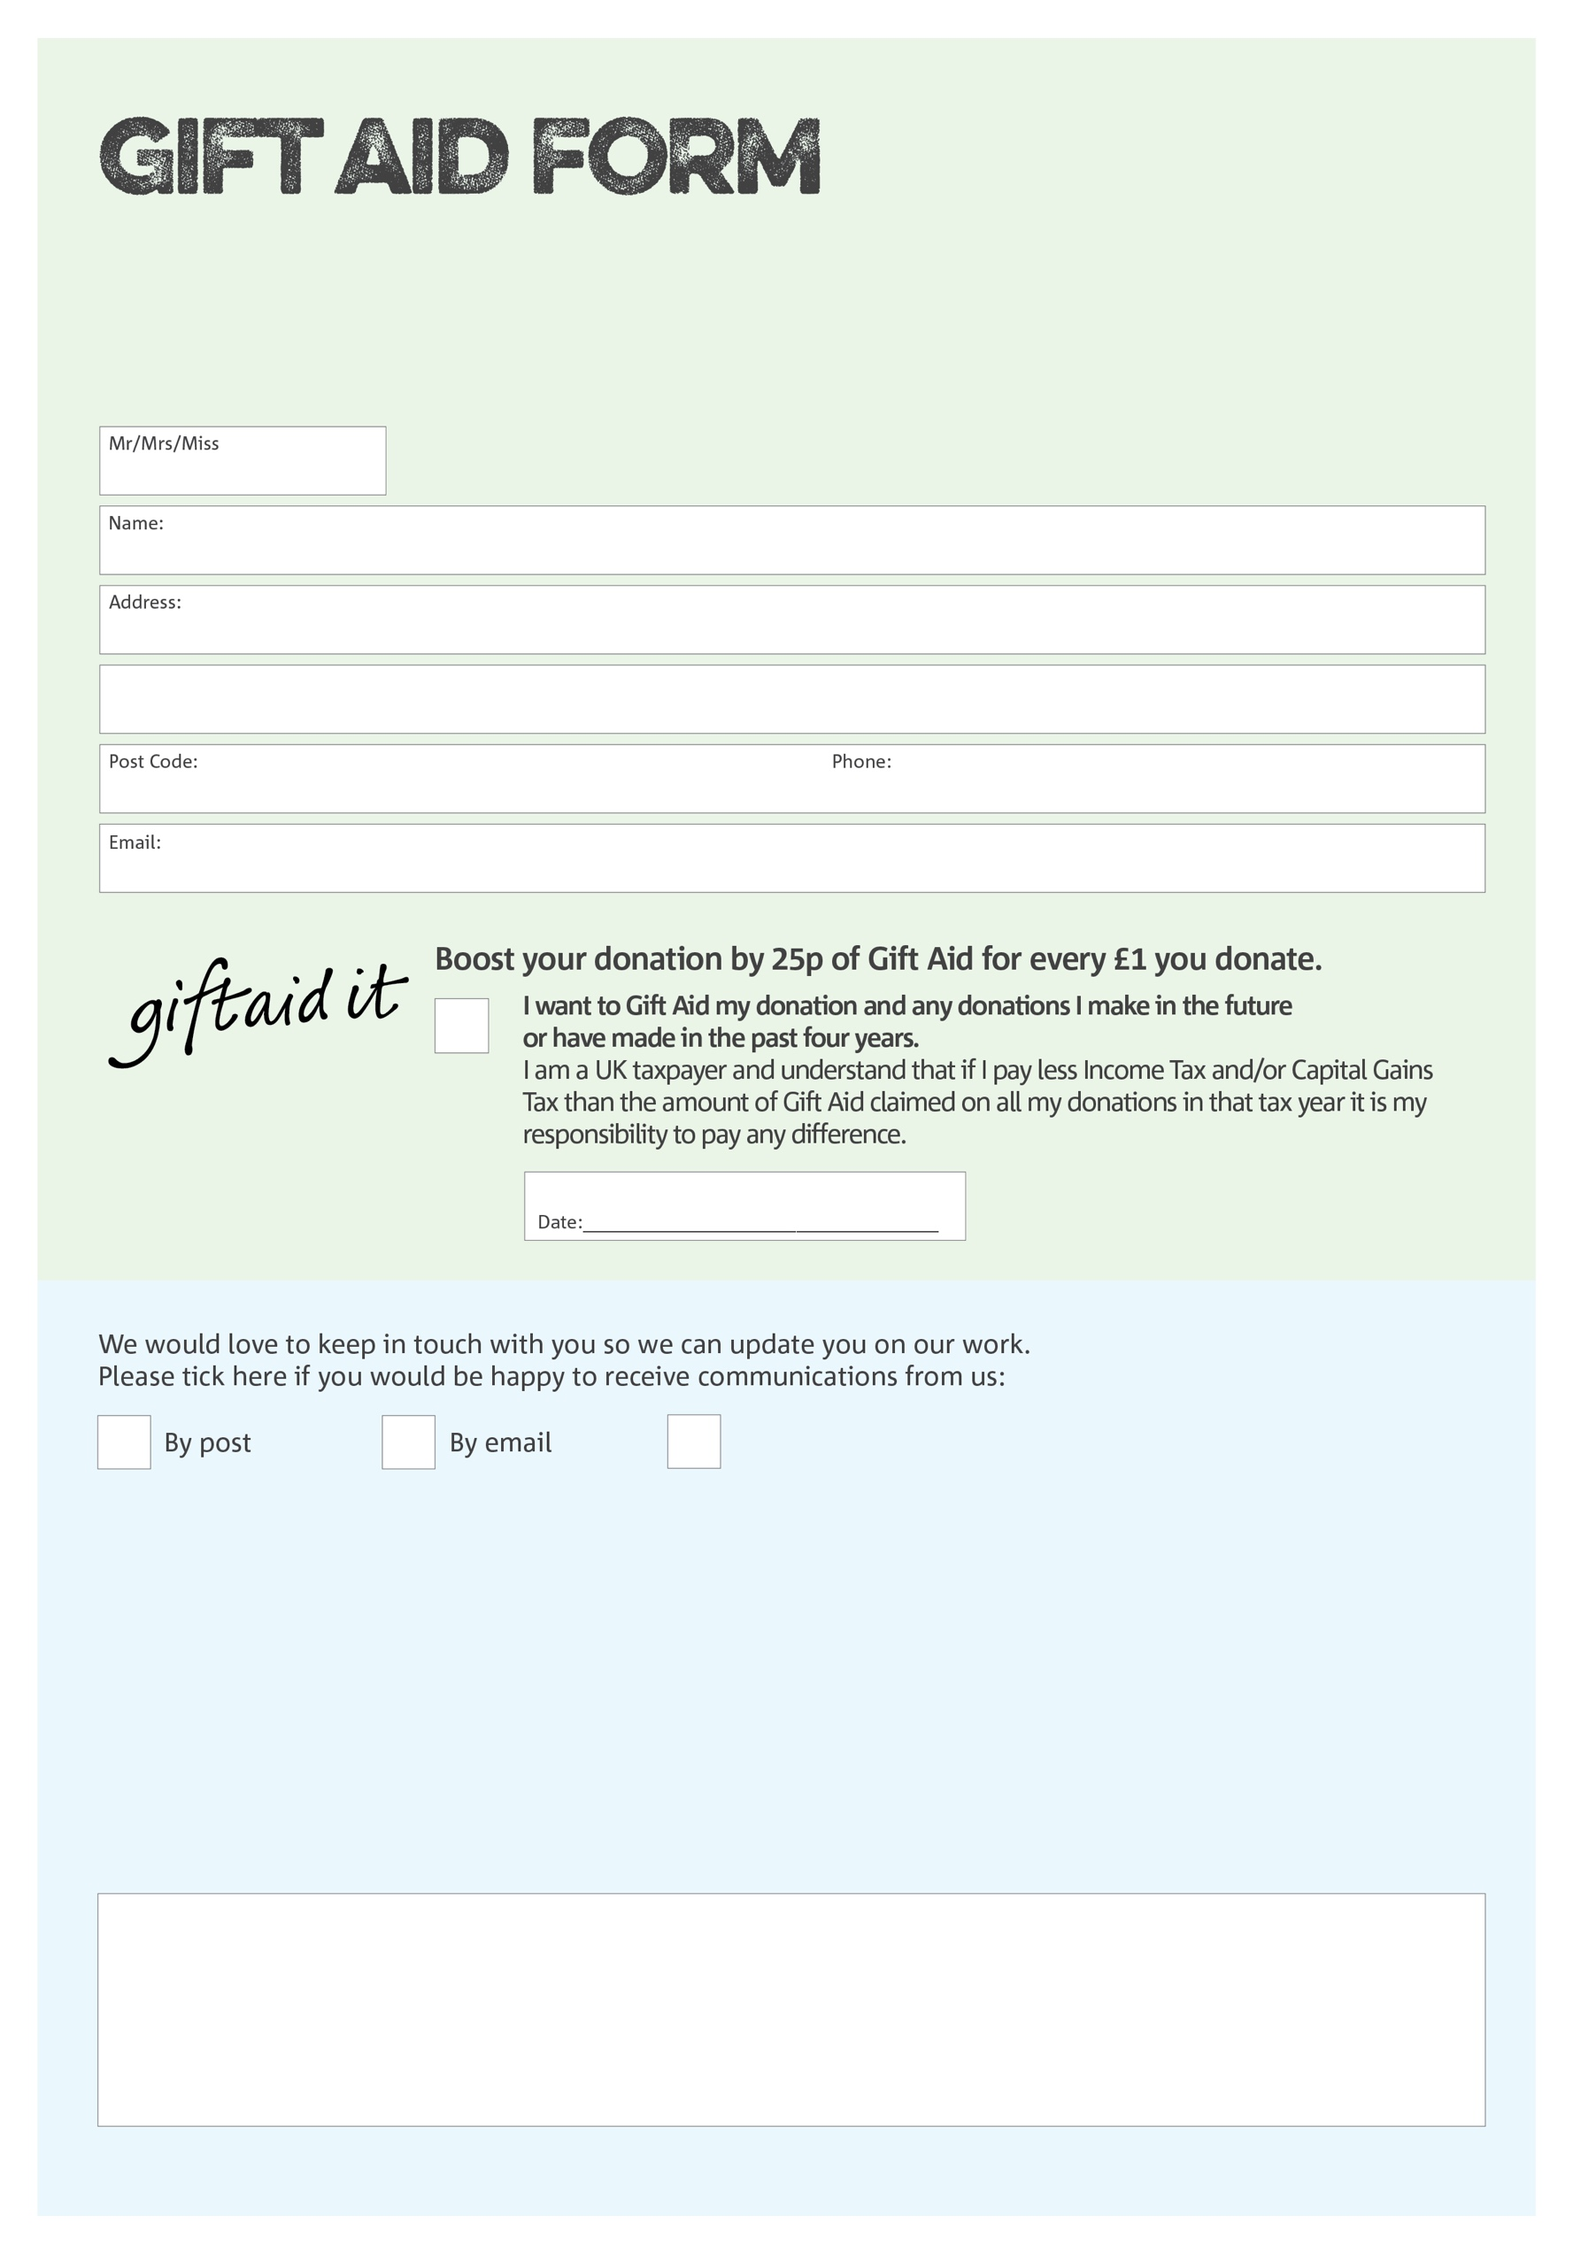
By filling in this form West Berks Foodbank will receive an extra 25p for every £1 you give at no extra cost to you. Thank you!

Liberty House, Greenham Business Park
Thatcham, Berkshire, RG19 6HS

Data protection

'West Berks Foodbank is committed to protecting your privacy and will process your personal data in accordance with current Data Protection legislation. West Berks Foodbank collects information to keep in touch with you and supply you with information relating to our work. To unsubscribe from our newsletter, send a message to the email address above with the word unsubscribe in the subject line. A full data privacy statement for financial donors is available from the foodbank on request.’

You can change your preferences any time by contacting us on 01635 49923 or emailing us at
info@westberks.foodbank.org.uk
I do not wish to receive future communications
from West Berks Foodbank
We would love to know why you have chosen to donate to West Berks Foodbank. If you would like to share your motivation let us know below:
Charity Number 1151996. Registered in England & Wales

