
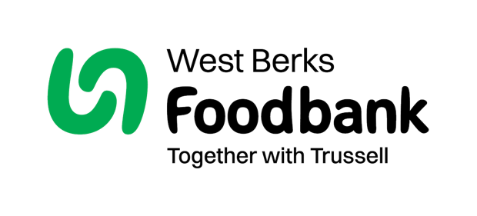
Sending in your Gift Aid form
Please send the completed form to: West Berks Foodbank, Liberty House, Greenham Business Park, Thatcham, RG19 6HS

westberks.foodbank.org.uk

Postcode:
Phone:
Address:
Please pass this form onto the food bank, using the food bank’s address at the bottom, who will save a copy for their records. They will then send it onto your named bank or building society.

Please pay West Berks Foodbank
6

0

4

6

7
8

7
2
5
9

7

7
5
0

–
–
Account number:
Sort code:
The sum of:
(in words)
(in figures)
Name of your bank
Branch address

–
–

Account number:
Sort code:
Until further notice and debit my account accordingly.
On the:
/
/
M
M
D
D
Y
Y
Y
Y
Each:

Month
Year

Week

Name of the account to be debited:
Date:
Signature(s):
Your details
Let’s keep in touch
Name:
Title:
Email:
To change your communication preferences at any time, please call us on 01635 49923 (Monday to Friday, 9am to 5pm) or email info@westberks.foodbank.org.uk.

No, please do not contact me via post
Mobile

Telephone

Email
We would love to be able to send you updates with information about our work, fundraising activities and ways to get involved. Let us know below how you prefer to be contacted by us:
If you are a UK tax payer, we can reclaim 25p for every £1 you give, that is an extra 25% on top of your gift!

Date:
I want to Gift Aid my donation, and any donations
I make in the future or have made in the past four years, to West Berks Foodbank.
I am a UK taxpayer and understand that if I pay less Income Tax and/or Capital Gains Tax than the amount of Gift Aid claimed on all my donations in that tax year it is my responsibility to pay any difference.

Registered charity number (1151996). Registered in England and Wales.
Data protection
West Berks Foodbank is committed to protecting your privacy and will process your personal data in accordance with the General Data Protection Act 2018. West Berks Foodbank collects information to keep in touch with you and supply you with information relating to our work. This includes informing you of fundraising that might be of interest to you. West Berks Foodbank will never sell or pass your details to anyone who isn’t directly working on our behalf.

Instructions to your bank manager
Standing Order Mandate

