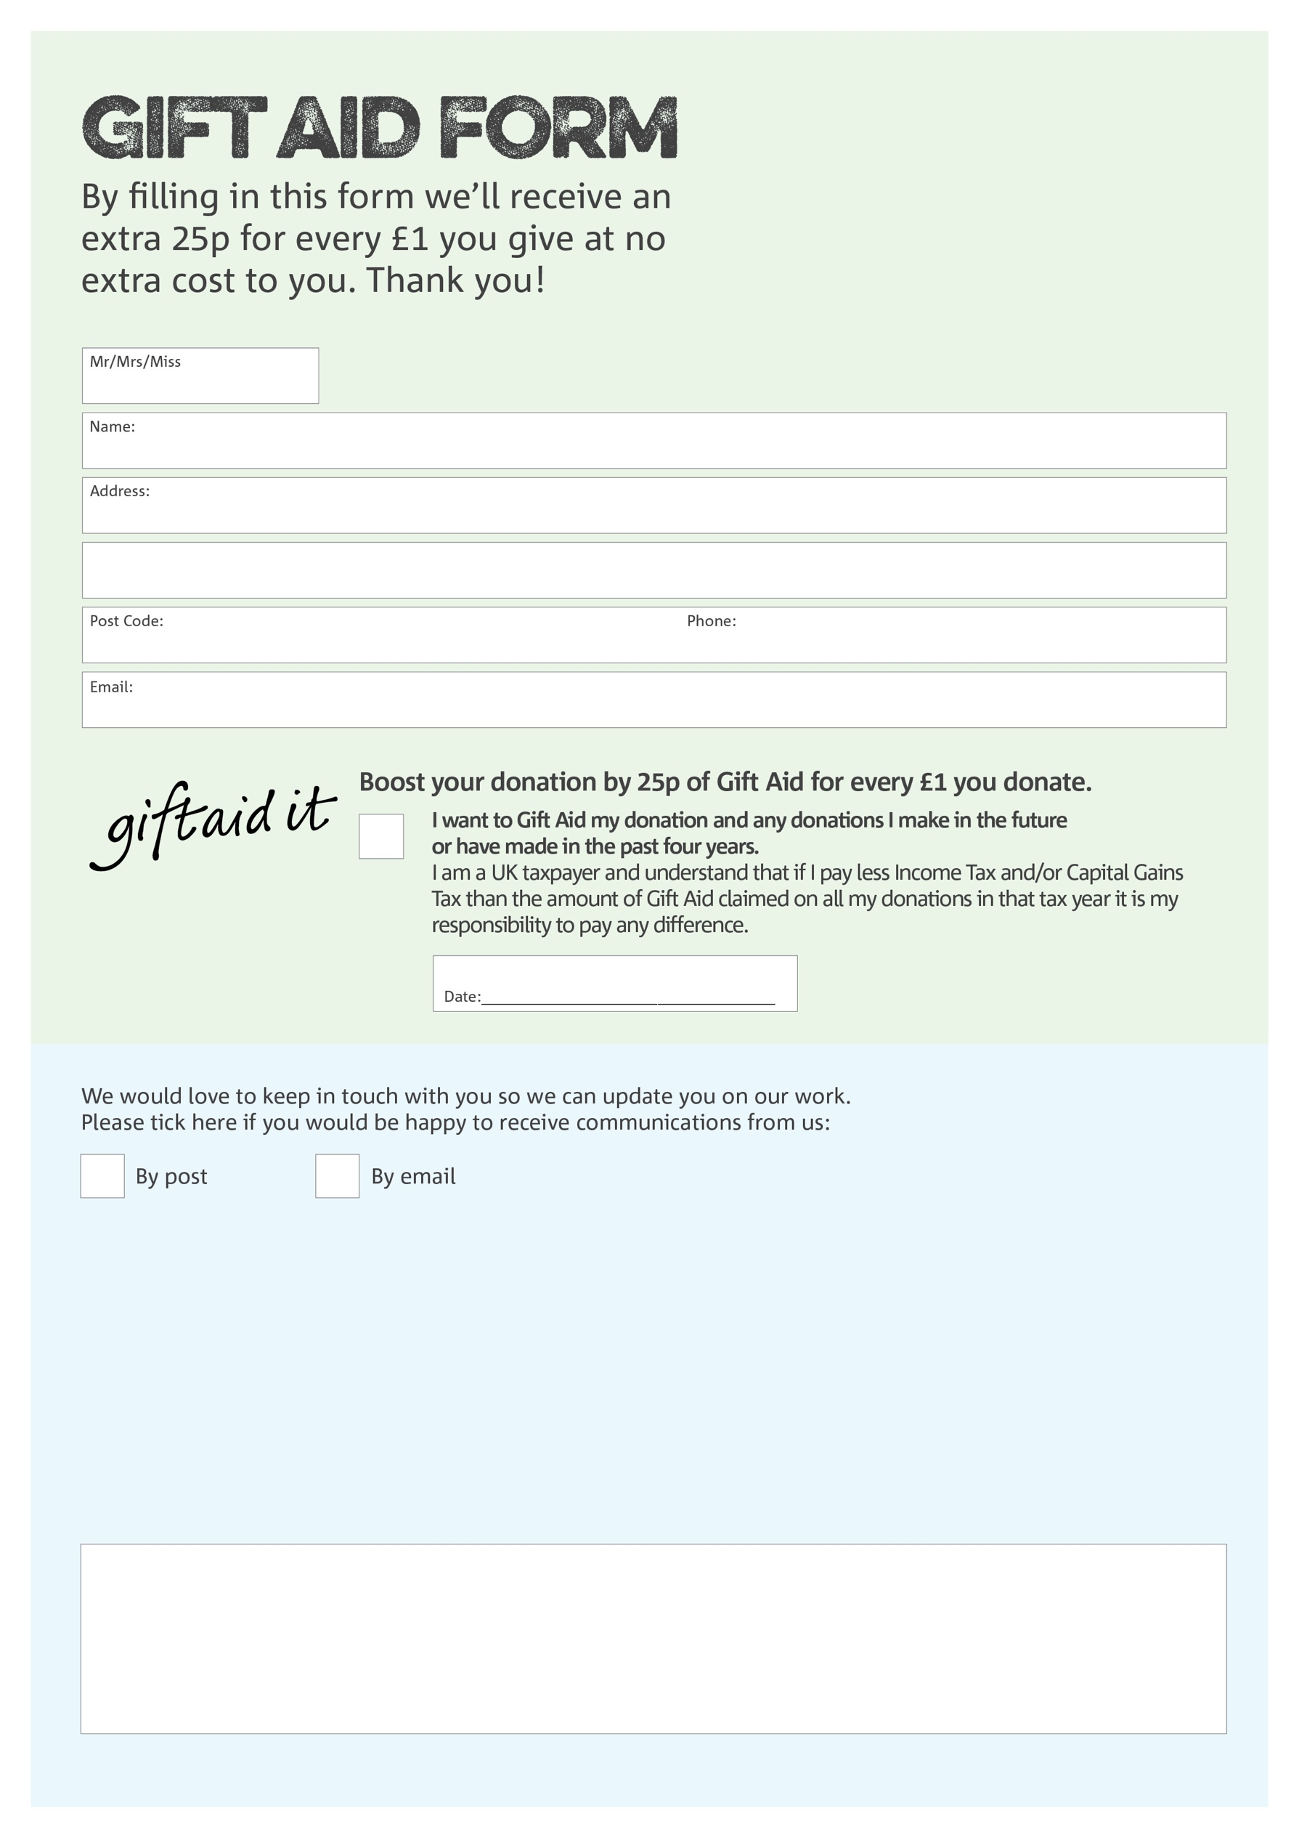

**Data protection**

West Berks Foodbank is committed to protecting your privacy and will process your personal data in accordance with the Data Protection Act 1998. West Berks Foodbank collects information to keep in touch with you and supply you with information relating to our work. West Berks Foodbank will never sell or pass your details to anyone who isn’t directly working on our behalf.

Charity Number 1151996. Registered in England and Wales

We would love to know why you have chosen to donate to West Berks Foodbank. If you would like to share your motivation let us know below:

You can change your preferences any time by contacting us on 07955 626621 or emailing us at

info@westberks.foodbank.org.uk