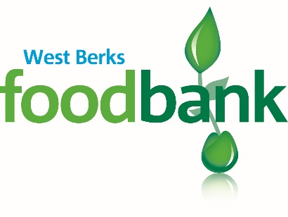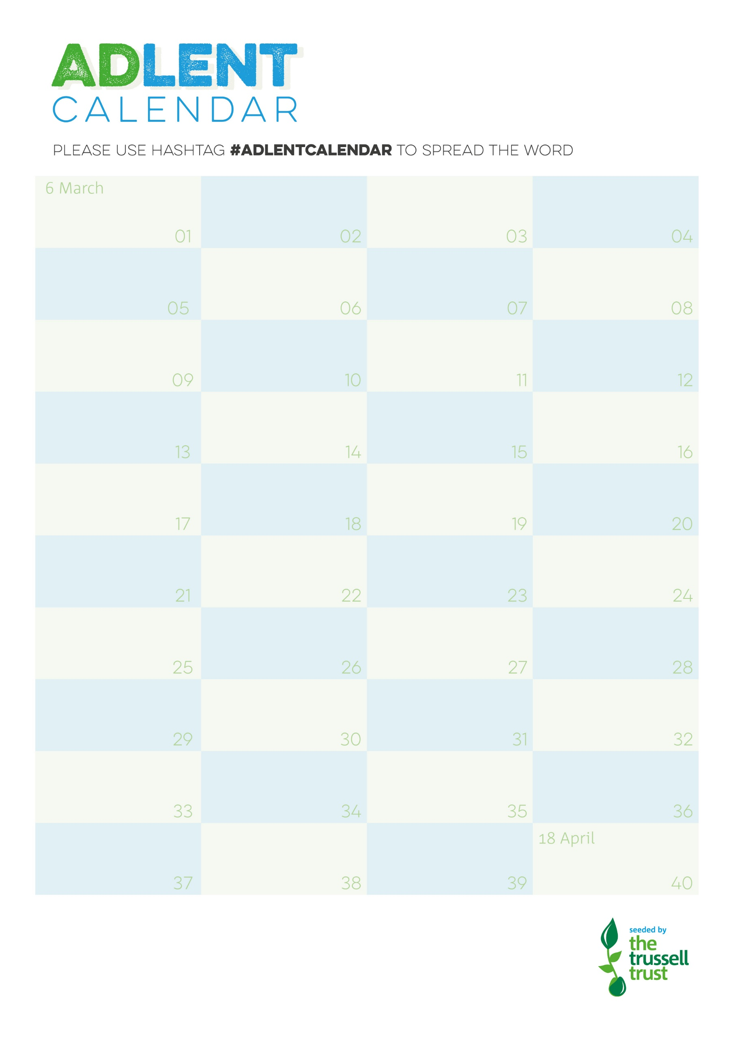

**WE CAN COLLECT AS PART OF YOUR NORMAL CYCLE OF COLLECTIONS WHEN YOUR BOX IS FULL OR WHEN REQUIRED**

**Please contact:** [collections@westberks.foodbank.org.uk](mailto:collections@westberks.foodbank.org.uk)

**During Lent please try to put one item each day into a collection box. Thank you!**

WBFB Reg Charity No 1151996 Reg in England & Wales

**Long Life Fruit Juice**

**Hot Cross Buns**

**Sponge Pudding**

**Custard**

**Chilli-con-Carne packet mix**

**Mixed Herbs**

**Tinned Fruit**

**Long Life Fruit Juice**

**Sunflower Oil 500ml**

**Tinned Vegetables**

**Kitchen Roll (2 pack)**

**Tinned Tomatoes**

**Rice Pudding**

**Coffee**

**Dried Onions (packet)**

**Tinned Meat**

**Dried Onions (packet)**

**Tinned Meat**

**Sponge Pudding**

**Chilli-con-Carne packet mix**

**Tinned Tomatoes**

**Rice Pudding**

**Tinned Meat**

**Mixed Herbs**

**Toilet Roll (2 pack)**

**Custard**

**Tinned Vegetables**

**Sunflower Oil 500ml**

**Sponge Pudding**

**Long Life Fruit Juice**

**Toilet Roll (2 pack)**

**Coffee**

**Sugar**

**Tinned Fruit**

**Custard**

**Rice Pudding**

**Tinned Tomatoes**

**Tinned Meat**

**Tinned Vegetables**

**Instant Mash**